Kevin Chung

10/2/19-10/4/19

Period 5

Journal 5

This weekend, I created a script that made it easier to slice an image into bounding boxes. Rather than trying to tune hyperparameters, the script just prompts the user to click on the four corners in the image, and then it segments the board from those corners using the segmentation script I made last week. This is so it will be easier for Kevin Fu to collect data, which he has already started, without having to deal with a flimsy board detection algorithm. Below are some examples of slices from the script I made.

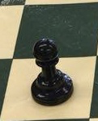 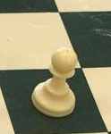

Additionally, I discussed with Dr. Gabor on possible complications that we will encounter in the future. For example, the pieces won’t necessarily be in the center of each square, they could be off-center or even in the middle of two squares. We aren’t sure how we are going to tackle this problem yet, but it could end up being a limitation of our software. Another complication is shown in the image below. There aren’t any pieces on the square, but the slice contains a piece from the side, which we don’t want to look at.

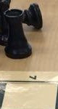

As for the board detection, I tried using an algorithm that took all the lines (after they were filtered out) and found the intersections between all of them and called those “lattice points”. Lattice points are the intersections of the lines on the board. It then took combinations of four from those lines and assumed they were the board boundaries. It then calculated where it thought the lattice points were from those four lines and counted how many matched up with the detected lattice points. Afterwards, it picked the four lines that had the most matches. However, my current implementation was unsuccessful, but I’m not sure why. My next step is to investigate why the algorithm isn’t working.